WARRANT OFFICER ASSOCIATION
CRATER CHAPTER # 0603
FORT LEE, VIRGINIA 23801

MEMORANDUM FOR RECORD 6 November 2019

1. The Chapter President, CW4 Dan Howison, called the meeting to order at 1730.

2. Quorum - 16 (31 proxies) present to conduct the meeting, 6 visitors; Pledge of Allegiance was recited.

NOTE: Joy Metzger, from the Fort Lee Chapter of the Holiday Helper Association gave a 15 minute information discourse that informed the Chapter on the upcoming December 11 Holiday Helper event and also a precursor volunteer effort. The volunteer effort is to have individuals with transportation (truck) to take one Dollar Tree Store, and as needed for the next six weeks, pick up stocking stuffers for the Holiday Helper Program..

3. We welcomed the following visitors:
- CW5 James Fiorilli, NG, assigned to ALU to the Ordnance Dean’s Team, will transfer membership to Crater Chapter
- CW4 Michael Theroux. Secretary at the Hawaii Aloha Chapter, here at ILE Follow-on
- WOCC/SFC Cortney Johnson, , Warrant Officer 923A February 20 Candidate
- CW4 Tollie Yoder, Reserve 922A CASCOM Joint Food
- CW5 Johnathon Waddy, newly affiliated Crater Member, Transportation Warrant
- CW4 Derrell Logan, Cyber Security Analyst in CASCOM, CW4 in NG, will ;transfer membership to Crater Chapter (Darrell is sponsored by CW5R Karen Ortiz)
- Joy Metzger. Holiday Helper Organization, Fort Lee Virginia

4. Minutes from the 4 September 2019 meeting, with October updates were reviewed by all. CW5 Travis Elliott made a motion to accept the minutes subject to edit, and CW4R Karen Ortiz seconded. Motion passed.

5. The Treasurer’s reports for September 2019 and October 2019 were read by all. CW5 Nicole Woodyard made a motion to accept the reports subject to audit, and CW4R Janice Chayt seconded. The treasurer’s reports for September and October 2019 passed. Volunteer for the Treasures “books” audit were CW4 Alex Blain, CW5R Karen Ortiz, and CW5 James Williams. No issues were noted on this audit.

6. Committee Reports:

a. Vice President Report CW4 Francis Pattin - Includes Membership statistics with reports from the Vice-President for Army Reserve/National Guard Affairs – CW5 James Williams- Vice-President for Retired Affairs – VACANT- and Vice-President for Junior Warrant Officer affairs VACANT- (VP-JWO) WO1 Tyrone Lander- see report.
b. Memorabilia – CW3 Karen Algernon-Wallace. See report. See report. Gave by CW4 Amy Scott
c. Volunteer Hour monitor- CW5R Vickie Vachon – see report.
d. Boy Scouts of America - CW4R Charlie Mills see report
e. JROTC High School Support – CW5 Nicole Woodyard
f. McGuire VA Support – CW5R Karen Ortiz
g. Rebuilding TriCities – CW5 Thomas Waltman -see report
h. Public Relations – CW5 Travis Elliott
.
7. Old Business.

a. CW4 Amy Scott briefed memorabilia. Memorabilia sales are going well and is ‘on fire.’ CW4 Pattin and CW4 McCracken have the memorabilia photos, prices and details and will place the information on the Crater Chapter Web Site and on Facebook.
b. CW4 Dan Howison did not attend AAM in Fort Campbell, and therefore the Crater Chapter will return $3000.00 from obligated status to the general funds in the Checking Account. CW5 Nicole Woodyard and CW4R Janice Chayt did attend the AAM and informed the quorum with highlights in key information points learned at the 2019 AAM.
c. CW5 Travis Elliott informed the quorum that the Walnut Hill Elementary School on 300 W South Petersburg, VA 2805 did not have Chapter participation. This effort was resolved by other means and is a closed effort within the Crater Chapter.
d. CW4 James McCracken provided an AAR on Fall Potluck. CW5 Travis Elliott assist. It was a successful event, and many have asked for this to be a repeat effort, with AAR lessons learned. To close this effort, names of those who attended will be provided to CW5R Vickie Vachon.
e. CW5 Travis Elliott leads the committee for a Warrant Officer Ball. April 25, 2020 is the choice date for the event. The plan is to use the 2015 plan. CW5 Elliott is coordinating the details. A site survey of the Marriott will occur next week with CW4 Pattin and CW5 Elliott.
(1) There was quorum discussion, led by CW4 Amy Scott to have a Golf Tournament in conjunction with the Ball. It actually began as a more sooner event, but was then suggested to take more committee time to plan and ensure the golf Tournament does not get close to a calendar event for one of the Fort Lee General Officers, which would take precedence to the Crater event, as has occurred previously, making us cancel. CW4 Scott will provide details at future meetings.
f. Rebuilding TriCities: CW5 Thomas Waltman now chairs that committee. Rebuilding TriCities is listed on calendar, and in Standing Orders as a supported action.
g. CW5R Wayne Burton still has one meal vouchers for 2, for Members’ present raffle. The proceeds from Refrigerator sales will purchase another. The Chapter also has two Krispy Crème DoNut certificates to raffle, donated by CW5 Sonia Graves-Rivera.
h. Holiday Helper date is 11 December 2019 from 1100-1300 hours. Helpers are CW4R Charlie Mills, WOCC SFC Courtney Johnson, CW5R Vickie Vachon, CW4 Dan Howison, CW5 Travis Elliott and CW4R Janice Chayt. Thus far CW4 Francis Pattin, CW4R Charlie Mills, CW5 Travis Elliott, are volunteers to transport items, a pre-mission to enable the Holiday Helper event. The names will be listed in the report.
i. Wreaths Across America event is December 14th at City Point National Cemetery (Avis St, Hopewell, VA 23860) starting at 11am.

8. New business:

- CW4 Francis Pattin will have his retirement ceremony 20 December, 2019 at the Quartermaster Museum at time TBD.
- CW5 Nicole Woodard will have her retirement ceremony 24 Jan 2020 at TBD location at time TBD.
- CW4R Janice Chayt wants to deliver cookies on Fort Lee during the Christmas Holidays and is interested in getting information to who her cookies can be delivered to and when.
- CW4R Chayt brought 3 coins from the AAM and a Wine Cigar glass for the Chapter. These items will be place in queue for presentation to visitors at Crater events, such as OPD, and seminars.

9. The next meeting will be held on Wednesday, 4 December 2019 at Suite E, Bldg. 10000, near Carver Avenue and Sisisky Blvd (the Hut) at 1700, gather for social and the meeting will begin at 1730 hours.

10. Motion to adjourn was made by CW5R Karen Ortiz and was seconded by CW4R Janice Chayt at 1850. Motion passed.
______________________ ______________________
Wayne Burton Dan Y. Howison
Crater Chapter Secretary Crater Chapter President

6 November 2019 Quorum
CW4 Dan Howison  CW5R Wayne Burton  CW4 Francis Pattin  CW4R Charlie Mills  CW5 Maria Martinez  CW3 Amy S. Scott  CW5 Travis Elliott | CW5 Nicole Woodyard  CW5 James Williams  CW4 James McCracken  CW4R Janice Chayt  CW5 Johnathon Waddy  % CW5R Vickie Vachon  CW4 Alex Blain | CW5R Karen Ortiz  CW4 Derrell Logan  ! CW5 James Fiorilli  ! CW4 Michael Theroux  ! WOC SFC Cortney Johnson  ! CW4 Tollid Yoder  ! Joy Metzger |  | * USAWOA member; not Crater Chapter member # membership unknown ! VISITOR  %Telephone Call in
ADDENDUM: Crater Chapter Proxies Held
Crater Chapter Standing Orders:
1. Chapter President is authorized discretion to fund administrative purchases of up to $500, provided the budget contains funding. Such expenditures will be reviewed in the next Treasures Report minutes.
2. Two Scholarships are funded annually. One to a dependent of a Crater Member present in the local area and one open to student attending college in local area from the tri-cities area or other member dependent. All funds in the Chapter Savings are for Scholarships. Deviation from two scholarships or amount change in any year are actioned with a quorum motion and voting. Application guidelines are published in the entry form available on the Chapter website.
3. Chapter Memorabilia Chair is authorized to fund replenishment of existing memorabilia lines from sales proceeds up to $999.00 limit.
4. Chapter Treasure is bonded and signs all checks for Chapter expenditures; with actions reported in following Treasurer’s reports.
5. Chapter sends a representative to the AAM each year if funding is available. Raised and obligated annually NLT July permitting best scheduling and bargain travel costs.
6. Crater Chapter supports the following community events as Old Business:
- Rebuilding Tri-Cities/Habitat-for Humanity
- Thanksgiving Baskets
- Wreaths Across America
- Holiday Helper
- Support for McGuire Veterans Home ($500 per year) or more as voted
All other community events are brought to the quorum as new business.

Name Expires Proxy given to:
CW5 Jose Agosto Mar 20 Open
CW4 Adriana Aldape Mar 20 Open
CW4R Percy Alexander Jan 20 CW5R Wayne Burton
CW4 Alex Blain Mar 20 Open
CW4R Hope Bean Jan 20 CW4R Amy Jones
COLR David Buck Mar 20 Presiding Officer
CW5R Wayne Burton Jan 20 Open
CW5 Travis Elliott Jan 20 CW5R Wayne Burton
CW5R Wayne Estes Mar 20 Presiding Officer
CW5 Roberto Figueroa Jan 20 CW5R Vickie Vachon
CW5R Sam Galloway Nov 20 President
CW5R Bob Gates Jan 20 CW5R Wayne Burton
CW5 Robert Gowin Mar 20 Open
CW3 Ryan Harman Jan 20 CW4 Dan Howison
CW4 Dan Howison Mar 20 Open
CW5 Guy Hunter Mar 20 CW5R Vickie Vachon
CW4R Richard Jefferson Mar 20 VP
CW4R Amy Jones Aug 20 CW5R Wayne Burton
CW4 Robert D. Johnson Jul 20 President or VP
WO1 Tyrone Lander Jul 20 Open
CW3 Joshua Martin Mar 20 President or VP
CW4R Luis Martinez Jan 20 CWR5 Vickie Vachon
CW5R Frank Meeks Jul 20 CW5R Vickie Vachon
CW4 Wayne Melesky Nov 20 Presiding Officer
CW4R Charles L. Mills Mar 20 CW5R Wayne Burton
CW4R Chester Morris Jan 20 Chapter President
CW4R Monty Meston Jan 20 CW5R Wayne Burton
Chapter BOD – Committee Structure
President+: CW4 Dan Howison dan.y.howison.mil@mail.mil Vice President+: CW4 Francis Pattin francis.w.pattin.mil@mail.mil Vice President for Army Reserve/NG Affairs –CW5 James Williams Vice President for Retired Affairs – OPEN VP Junior Warrant Officer affairs - (VP-JWO) WO1 Tyrone Lander @Membership – Filled by VP, VP-RA, VP RS-A, Memorabilia - CW3 Karen Algernon-Wallace karen.a.algernonwallace.mil@mail.mil *Rebuilding Tri-Cities – CW5 Thomas Waltman @Nominations/Elections Committee – CW5R Wayne Burton & CW5R Vickie Vachon *Volunteer hour Monitor - CW5 Vickie Vachon (pokeandprod@aol.com ) *Holiday helper – CW5R Vickie Vachon *Web-Master – CW3 James McCracken james.mccracken13.mil@mail.mil *Boy Scouts Of America ( + Cub Scouts) CW4R Charlie Mills *JROTC High School Support – CW5 Nicole Woodyard + CW4 Jenn Walker *McGuire VA Support – CW5R Karen Ortiz *Crater 100th Committee - CW5 Nicole Woodyard *Resolutions/ Parliamentarian - CW5R Wayne Burton *Chaplain – OPEN *Warrant Officer Ball – CW5 Travis Elliott *Public Relations – CW5 Travis Elliott
Treasurer # – CW4R Charles Mills ( charlieandada@gmail.com ) Secretary# – CW5R Wayne Burton (waynebrv@yahoo.com; marion.w.burton.civ@mail.mil)
*Special Committee + elected office # appointed office @ Committee IAW Bylaws
Note: All Elected/Appointed Officers and Committee leads will serve on Crater BOD.

All committee members & appointments are installed and removed at discretion of the Chapter President IAW current Chapter Bylaws
CW3R William King Mar 20 Presiding Officer
CW5R Karen Ortiz Jan 20 CW5R Vickie Vachon
CW3 Dan Peoples Mar 20 CW5R Wayne Burton
CW4 Francis Pattin Jan 20 CW5R Wayne Burton
CW4R Allan E Rickard Mar 20 Presiding Officer
CW4 Wayne Sexton July 20 Open
CW5R Alvin Taswell Aug 20 Open
CW5R Vickie Vachon Jul 20 President or VP
CW4 Ted Vanzant Mar 20 CW5R Wayne Burton
CW4 Clenora ”Jenn” Walker Mar 20 Open
CW3 Gabriela Wetherington May 20 CW4 Francis Pattin
CW5 James Williams Mar 20 Open
CW5 Nicole Woodyard Feb 20 Open
CW4R Donna Zampi Oct 20 President

Proxies used:
Bronze Level - Eagle Rising Recipients:
CW5R Wayne Burton CW4 Dan Howison
CW4 Ted Vanzant CW5 Nicole Woodyard USAWOA
CW4 Francis Pattin CW4R Charlie Mills

Silver Level - Eagle Rising Recipients
CW4R Amy Jones CW5 James Williams
CW5 Nicole Woodyard USAOWA

Gold Level - Eagle Rising Recipients
CW5R Vickie Vachon CW5R Wayne Burton
CW5 Travis Elliott CW5 Nicole Woodyard USAWOA
CW5 Guy Hunter CW5R Karen Ortiz

Note: CW4 Aldape and CW2 Pick are no longer Crater members

Presidents’ Report – Verbal report at meeting.
Vice Presidents’ Report
Vice President NOTES:
CW3 Francis Pattin– Chapter Vice President, CW5 James WIlliams VP – Reserve/NG Affairs, and VACANT VP- Retired Affairs WO1 Tyrone Lander
NOTE: Revalidation is at least a 6 month process, therefore POA revalidation efforts must begin in February 2020, to meet Oct deadline.
Crater Chapter POA revision will be as the Crater Silver Chapter, USAWOA

Crater 2019-2020 Calendar Events
4 Dec Chapter Meeting – HUT
- Audit
- 11 Dec- Holiday Helper execution
- 14 Dec Wreaths Across America
- 28 Dec Visit McGuire Veterans Hospital

8 Jan 2020- Swear in elected new officers
5 Feb 2020 – Crater paperwork needs filled out and submitted for Private Organization Revalidation
VP Report - Roster

VOLUNTEER HOURS
Volunteer hours as of 2123 hours 2 December 2019 are:

Members - 4023.5

Guest - 319.50

This does not include individual BOD hours or the hours for the Dollar Tree pick up, still need those.

Volunteer Hours (Need ages of volunteers always if younger than 18)

ADW | 59
RET | 71
ARW | 5
NGW | 6
ASC | 1
Life | 71
Total | 143

Crater Meeting Call in Number
1-712-770-5505
Access Code: 501219
Calling in to the Crater Meeting is like being here in person. If you are a member, YOU may participate, open motions, offer seconds, discuss and vote. We all are busy, and the Crater Chapter steps up to the 21st Century with live telephonic meeting!

26 October Potluck Attendees
- CW4 James McCracken WO1 Alberto Fregoso
- Lovely McCracken CW4 Duncan Raimond Claxton - CW5 James William Fiorilli WO1 Jocelyn Griffin - CW4R Charlie Mills WO1 Alberto Fregoso - Ada Mills CW5 Maria Martinez - CW4 Amy S. Scott Chantel Martinez - CW5 Travis Elliott WO1 Allan Josiah - Sabrina Elliott Ashia Elliott age 16 - CW5 Thomas Waltman WO1 Pablo Gonzales - Lisa Waltman WO1 Richard Sayer - CW5 Joseph Giusto WO1 Benjamin Wright - CW5 Yenny Giusto Nathan Giusto age 5 - Gianna Giusto age 3 Giuliana Giusto age 3 - Cerelia Spencer Solomon Spencer age 7 - CW5 Clinton Dawkins
This is a close action

Boy Scouts of America, Troop 912, Ft Lee Va.
November HAPPENINGS
During troop meetings, Adult and youth leadership had discussions of upcoming events and plans for training activities.

Training events:
PLC selection
Cold weather Training
Conducted food drive
Event:
15-17 Nov, Campout
Climbing at new rope course and working on rank requirements.
Scouts enjoyed a great day on the ziplines
Weeblow to Boy Scout crossover ceremony was conducted.

Charles L .Mills
USAWOA, Crater Chapter
Charter Organization Representative
McGuire Veterans Hospital Christmas Event
McGuire Christmas event is scheduled for Saturday 28 Dec 2019 from 1230-1530. Volunteers will help the veterans with the Bingo cards, pass out snacks, canteen bucks, and clean up the multi-purpose center upon completion of the event.
Where: 1st Floor McGuire Multi-purpose Room Who: All veterans who like to play Bingo usually about 40 -50 people
Funds: $300 has been designated for snacks and canteen bucks
Date: 28 Dec 2019 1230-1530
Volunteers needed this is a great event and you will definitely have a grand time supporting the veterans.

POC CW5R Karen Ortiz.

Memorabilia
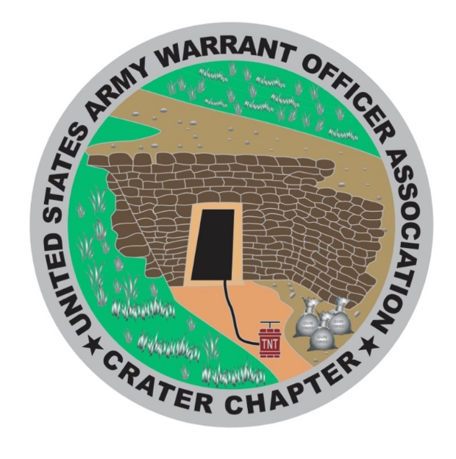
Proposed Calendar Year 2020 Events:
8 Jan 2020 Chapter Meeting - HUT
Wreaths Across America volunteers will show up and distribute wreaths Saturday December 14th at City Point National Cemetery (Avis St, Hopewell, VA 23860) starting at 11am. Also Chapter members will capture photos. We will not be selling wreaths/ conducting fund raisers for it this year due to our timeline.
Recommend we discuss in July 2020 meeting and nominate/ assign a committee lead to begin research and planning for 2020. POC: CW4 Dan Howison

JR ROTC update. CW4 Dan Howison will dig back to find the requirements decided previously and will solicit to the schools to see who will participate this year. (This is just for the public high schools, not including the school Nicky is partnering with.) (As Dan steps down from office he is willing to take on [officially] this effort [local public high schools] if the new officers wish. We can discuss in quorum at an appropriate time if needed.)

WO Ball 2020 Update:

On 2 Dec 2019, the Ball Committee Co-Leads, CW4 Pattin (Crater Chapter VP) and CW5 Elliott, visited the Richmond Marriott to coordinate the Joint Services Stateside Warrant Officers Ball for 25 April 2020. We met with Ms. Meredith Hall (Senior Catering Sales Manager) and provided our requirements.
We are currently planning between 175 - 200 attendees with reservation for 25 sleep rooms and an additional room for childcare services. Ms. Hall will email a price quote and let us know if 25 April is available – alternate date 18 April. CW4 Pattin is also working another quote from another hotel. Additional updates will be provided after quotes are received.

POC: CW5 TRAVIS T. ELLIOTT,

- Swearing in New officials
5 Feb 2020 Chapter Meeting - HUT
- Post Crater Silver Chapter Scholarship info in Ft Lee Traveler
4 Mar Chapter Meeting - HUT
- Decision for more than 2 Scholarships??
1 Apr Chapter Meeting - HUT
- Close Scholarship acceptance (1 April 2019)
- Audit
25 April 2020 Crater Silver Chapter WO Ball
- Committee has three members right now and looking for ideas from members
to make this a fantastic event
6 May Crater Silver Chapter Meeting
- Announce scholarship winners
3 Jun Crater Silver Chapter Meeting - HUT
- No current agenda at this time
8 Jul Crater Silver Chapter Meeting – HUT
-Establish Wreaths Across America Committee lead
- Audit
5 Aug Chapter Silver Chapter Meeting - HUT
-Accept Nominations - approve Ballot
2 Sep Warrant Officer Meet & Greet - HUT TIME -TBD
- Final date to approve Ballot
7 Oct Crater Silver Chapter Meeting - HUT
TBD Oct 48th AMM Redstone Arsenal, AL - Details to follow
- Habitat for Humanity
- McGuire Veterans Hospital Visit Planning list
- Present post with donation for Thanksgiving
- Audit
4 Nov Crater Silver Chapter Meeting - HUT
- Holiday Helper planning list
- Wreaths Across America planning list
- Election Vote
- Present post with donation for Christmas
2 Dec Crater Silver Chapter Meeting - HUT
- Announce election results
- Holiday Helper execution
- Visit McGuire Veterans Hospital
- Wreaths Across America
- Audit
13 Jan 2021- Swear in elected new officers

USAWOA CRATER CHAPTER
Treasurer’s Reports
1 November 2019 – 30 November 2019

Checking Account Fort Lee Federal Credit Union- Balance previous month $ 2,715.78

INCOME:
Income Total $ 000.00 + $ 0000.00

Expenses:
Meal (Papa Jon) $ 37.83
Picnic $ 11.97 Check # 136
ACS $ 250.00 Check # 137
Expenditures Total: $ 299.80 - $ 299.80 Total Revenue = $ 2,415.98 ---------------------------------------------------------------------------------------------------------------------
Savings Account Fort Lee Federal Credit Union - Balance previous month $ 3,063.47

Income:
Interest $ 0.00
Expenditures: None
Saving Account Balance: $ 3,063.47 $ 3,063.47
----------------------------------------------------------------------------------------------------------------------

PLEDGED PAID
Mail Box: $ 62.00
Liability Insurance: $ 268.00 $ 268.00
Bond: $ 114.82 $ 114.82
Scholarship Member: $1,000.00 $1,000.00
Scholarship Community: $1,000.00 0.00
Thanksgiving Donation: $ 250.00 $ 250.00
Christmas Donation: $ 250.00 $ 250.00
AMM: $3,000.00 $ 000.00
Scouts – BSA: $ 200.00 $ 200.00
Veterans Home: $ 300.00
TOTAL $6,444.82 $2,082.82 Remaining pledge $362.00

Charles L. Mills Dan Y. Howison
CW4(R), OD CW4, OD
Crater Chapter Treasurer Crater Chapter President

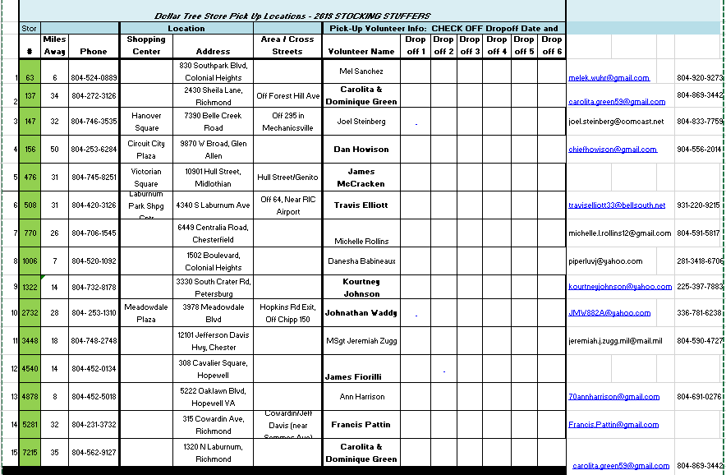

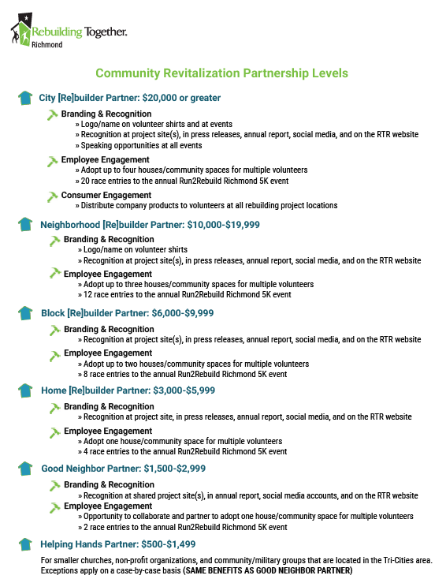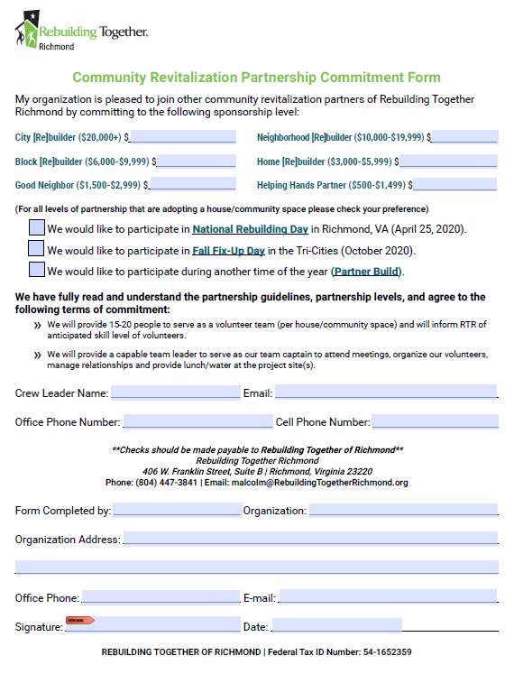
Agenda December 4th, 2019 meeting
1. Count of members to ensure a forum/forum established ( ) ID Proxies ( )
2. Call meeting to order at _________________
3. Pledge
4. Welcome guest and new members
5. Minutes passed out and read, any discussion, motion to accept subject to edit
Motion made by ________________________________
Seconded By ___________________________________
6. Treasures Report read and any discussion, motion to accept subject to audit
Motion made by_________________________________
Seconded By ____________________________________
7. Committee Reports
a. Vice President Report CW4 Francis Pattin – CW5 James Williams- WO1 Tyrone Lander
b. Memorabilia – CW3 Karen Algernon-Wallace.
d. Volunteer Hours - CW5R Vickie Vachon.
e. Holiday Helper - CW5R Vickie Vachon.
f. Boy Scouts - CW4R Charlie Mills
g. Solicitation – CW5 Nicole Woodyard
h. JROTC – CW5 Nicole Woodyard.
i. WO Ball – CW5 Travis Elliott
j. Rebuilding TriCities – CW5 Thomas Waltman
k. Public Relations – CW5 Travis Elliott
8. Old Business

What’s in it for me? –action
Proposed Christmas Event At McGuire Veterans Hospital –action
Chapter coin review – action

9. New Business –

10. Alibi’s
11. Next Meeting - 15 January 2020- Suite E, Bldg. 10000, near Carver Avenue & Sisisky Blvd (the Hut) at 1730 for the swearing in ceremony.
12. Adjourn meeting at (time) _________________________
Motion made by__________________________________
Seconded by _____________________________________

CRATER CHAPTER NOTES:
______________________________________________________________________________________________________________________________________________________________________________________________________________________________________________________________________________________________________________________________________________________________________________________________________________________________________________________________________________________________________________________________________________________________________________________________________________________________________________________________________________________________________________________________________________________________________________________________________________________________________________________________________________________________________________________________________________________________________________________________________________________________________________________________________________________________________________________________________________________________________________________________________________________________________________________________________________________________________________________________________________________________________________________________________________________________________________________________________________________________________________________________________________________________________________________________________________________________________________________

